COMP3850 PACE, S2 2026.
North Sydney Council - Extracting & resolving wildlife data to populate websites.

Hello students,
thank you for your interest in working on the NSC Wildlife Watch project:
https://www.northsydney.nsw.gov.au/help-environment-1/join-wildlife-watch!
What is Wildlife Watch?
Wildlife Watch is a citizen science program that is celebrating 30 years since it’s launch in 1996. We have digitised over 30,000 records. People have been walking around the Council area and writing down what wildlife they see, so we have a record of what lives where and when.
Why is this work important?
This information is used locally to help manage natural areas. When online, it can be viewed by anyone and can help inform the work they are doing (eg. research, creating regional strategies or state development works).
NSC WW History.
People used to write on paper records when they were out in the field (this occurred from 1996 - 2020). The information was later typed into a Bushcare database using Microsoft Access in the Council office.
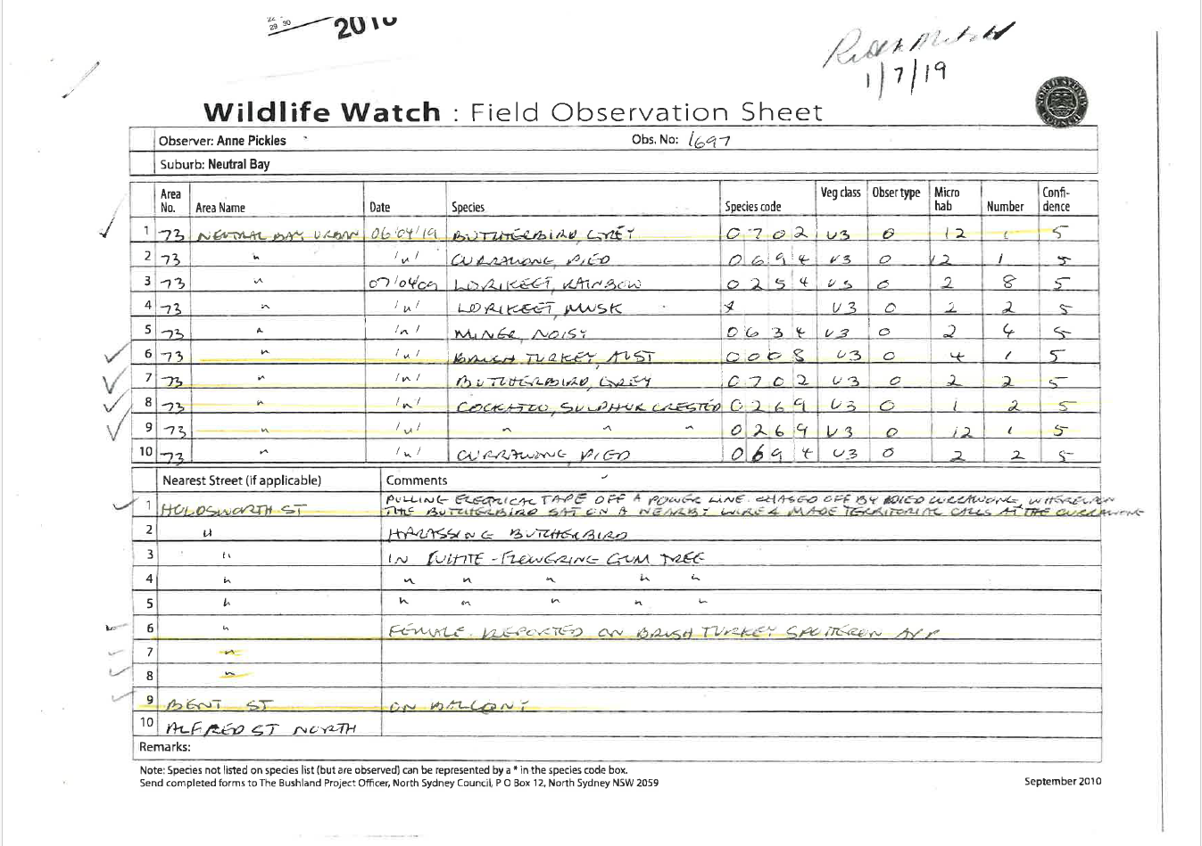

Since 2020, people can now enter data directly online – we have created a project called Wildlife Watch NSC on a website called BioCollect: https://biocollect.ala.org.au/acsa/project/index/da35ca9a-d725-4cb6-ae2e-d1cedebab1ba. Here you can see everything that has been entered online.
Note: if you see records that are older than 2020, that is because a volunteer has been entering some old paper records from our archive into BioCollect (the old MS Access database is no longer used).
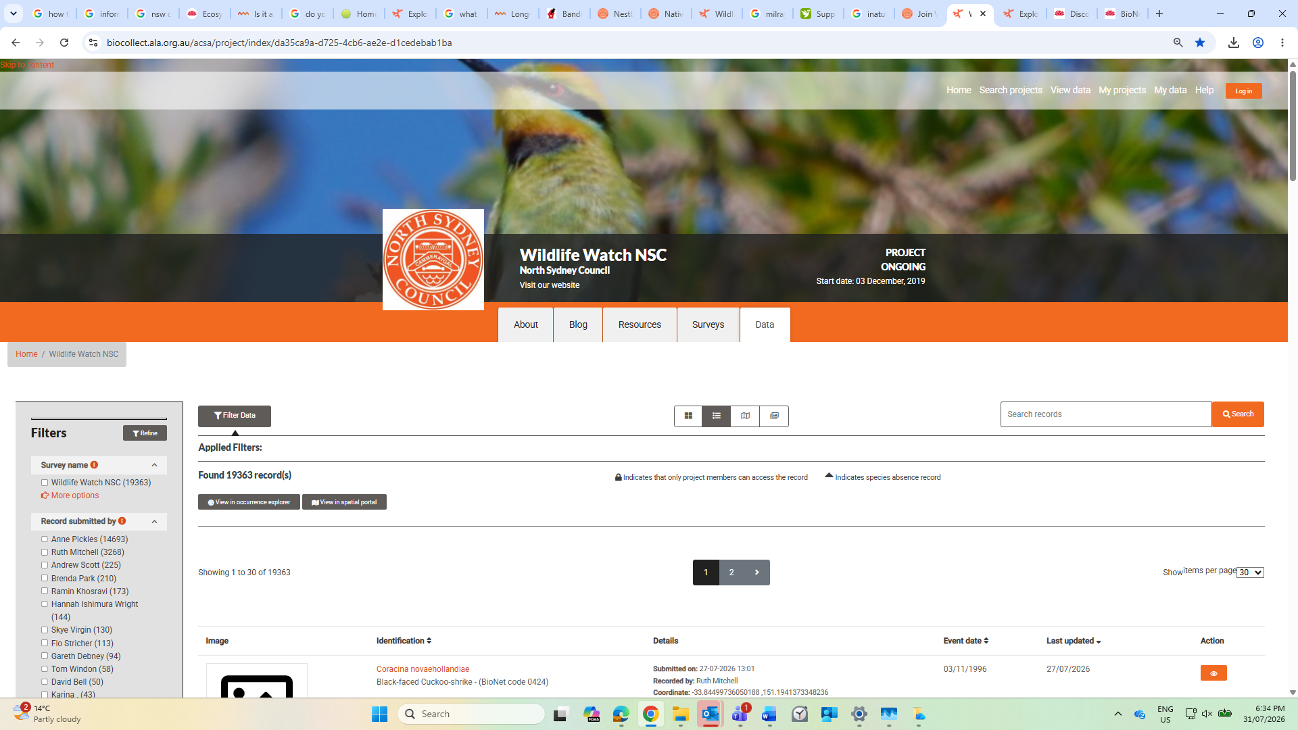

Why do we need your help?
We have data stored in a few different areas, in a few different ways. We would like all of our records to be online.
How can you help?
In two main ways:
- Updating two existing spreadsheets we have, so they are ready to go online and populate websites.
- Scanning (the data in) old paper records held in our archive and identifying any not yet recorded in the above two files.

Ok, so more on these two tasks…
Task 1 (Updating two existing spreadsheets, so they are ready to go online and populate two websites).
What needs to occur?
In order for our data to go online, it needs to be in a certain format to be accepted. This is where we get the format from: https://www.environment.nsw.gov.au/publications/bionet-atlas-fauna-survey-upload-datasheet
We have two sheets that are almost complete. These are called: ‘Bushcare updated’ and BioCollect updated’. The Bushcare file is everything that was on the old Access database at Council. The BioCollect file is everything that was on the BioCollect website (up until late August 2024). The only thing these two files need to have adjusted is some of the observer names.
Task1 (a). The Bushcare updated file has all of the observers listed as ‘North Sydney Council’. We have the names of the observers in our old Access database and the only way it spits them out is on a ~1300 page PDF in a way that looks like the original paper forms. We need to have the names of the observers alongside their wildlife observations in the Excel sheet, ready for upload.
Task 1 (b). The BioCollect updated file has everything that was on the BioCollect website until late August 2024. (Note: it also has some of the old paper records now going into it, pre 2020).
The BioCollect updated file needs a little tweaking before it is ready for uploading. Approximately 750 records have an incorrect name. They have the name Ruth Mitchell where it should read another volunteer. The correct names are being changed online, but have not been changed in the Excel file. What needs to happen? The correct observer names need to be allocated to their corresponding wildlife observations on the Excel file. To this end, a file with Ruth’s entries has been extracted from the BioCollect updated sheet and she has highlighted lines to alter with colours representing different people. The name that corresponds to a particular colour can be found in the bottom tab of the file called ‘Legend’. Note: let’s cut out Ruth’s entries that are not yet coloured from our BioCollect updated Excel file, as these can be corrected and uploaded at a later date.
Tip: if you need to sort data in Excel, make sure to 'expand the selection' and retain the whole row of data together (the species name, observer name, date, location, etc).

Task 1 (c). NSC can do this. Fill in the recent gap in BioCollect data recorded in Excel - the period from August 2024 to August 2026.

What do we need to do? Download data from BioCollect for this time period and prepare an Excel spreadsheet, like the others, ready for upload to BioNet.

…
After the existing two files are corrected, plus the new BioCollect file is created...at our end, we will upload the Bushcare file to the BioCollect website, then we will offer both the Bushcare AND BioCollect files to the NSW Government BioNet Atlas: https://www.environment.nsw.gov.au/news/discover-new-bionet-atlas-map-viewer-application
(if there are any duplicates found from the old Bushcare file, their system can remove these).
…

If we can achieve Task 1, that would be fantastic!
If we can tackle Task 2, that would be great...

Task 2 (Scanning (the data within) old paper records held in our archive and identifying any sightings not yet recorded in the above Excel files).

What is the ideal? To have every single wildlife observation listed in the old paper archives, online. Where are we at? In the past, often it was just the less common or more unusual observations that were entered into the Bushcare database. (You can see on the paper record pasted earlier, that only 5/10 entries were entered (signified by a tick beside the observation)). This means there are sheets with only some sightings on them digitised. It is those observations written on each sheet that were not digitised that we want to identify and prepare for upload.

How do we do this? Good question - this is where the magic of AI may come in. With its ability to read the old records, comparing them against the data in our Excel files – we hope that it can correctly identify any observations not yet digitised. This is something to discuss with your lecturer, as to the programs available for such work.

Do you first need to collect a sample of records, then train the AI to read the particular person’s hand-written notes on the paper? (Different people have different hand-writing and ways of marking information entered). The AI would need to understand that when inverted commas are used underneath words, this means those words are repeated...until the next word/s appear. It must be able to match the numbers on the lower half of the page (containing observation notes) to the numbered species sightings on the top half.

Let us know if you need us to scan the documents, then email them to you in a particular file type, or how this can work with your technology.

Thank you!

…

What is a fun way to view the NSC Wildlife Watch data?
The data from our NSW WW project on the BioCollect website is placed together with that from other projects on the Atlas of Living Australia (https://www.ala.org.au/). If you go to ‘Search & analyse’, then ‘Explore your area’ and type in ‘North Sydney’, you will see a map showing what wildlife people have seen, where and when.

Try collecting data yourself to add to the website, or get to know your local plants and animals using iNaturalist (https://www.inaturalist.org/). This app can identify species for you and record them at the same time!

